

VOLUNTEER ROLE: | Prevention Evaluation Volunteer
DIRECTORATE: | Prevention
TEAM: | Home Safety
LOCATION OF ROLE: | Merseyside Fire & Rescue Service HQ, Bridle Road, Bootle, L30 4YD
DIRECTLY RESPONSIBLE TO: | FSD Manager

LEADERSHIP BEHAVIOUR LEVEL: | Leading Yourself

MAIN ROLE PURPOSE
To support the Home Safety Team in evaluating the impact and effectiveness of their HFSC and S&W activities, by making outbound phone calls to members of the public following their Home Fire Safety Checks (HFSC’s)/Safe & Well (S&W) visit, asking a number of pre-set questions and recording the responses on our internal database, CFRMIS.

The post holder will be committed to encourage and promote the values of MFRS, the National Core Code of Ethics for Fire & Rescue Services, and act in accordance with the service values and behaviours.

KEY AREAS OF EXPECTATION
- To make outbound phone calls and complete survey questions to set targets.
- To accurately upload and maintain survey responses on CFRMIS.
- To follow templated scripts when asking survey questions.
- To signpost any questions or concerns disclosed by members of the public to the call centre line manager
- Complete any relevant administration tasks
- Complete a minimum of 28 hours per month (Monday – Friday between the hours of 9am – 5pm)
- Be aware of and complete learning to understand relevant MFRS policies and procedures e.g. Safeguarding, GDPR.
- Demonstrate and adhere to MFRS Values Behaviours & Code of Ethics.
- Volunteer responsibly and actively promote safe working practices with self and others.
- Attend any training relevant to the role to improve knowledge

VALUES, BEHAVIOURS AND CODE OF ETHICS
As detailed in the Authority’s CRMP, the Leadership Message clearly states our Values.

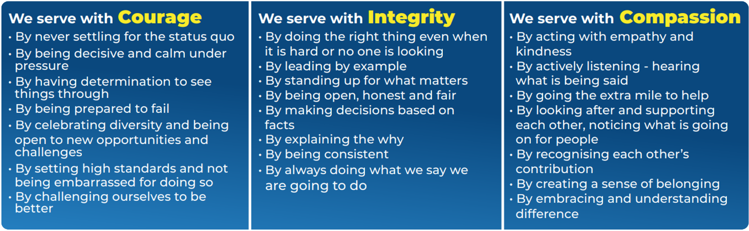

The National Core Code of Ethics for Fire & Rescue Services sets out five Key Principles, which provide a basis for promoting good behaviour and challenging inappropriate behaviour. The code is complemented by MFRA’s Ground Rules, which outlines how we welcome difference and individuality, create a sense of belonging in the most inclusive way and provide some key, simple rules surrounding how we act.

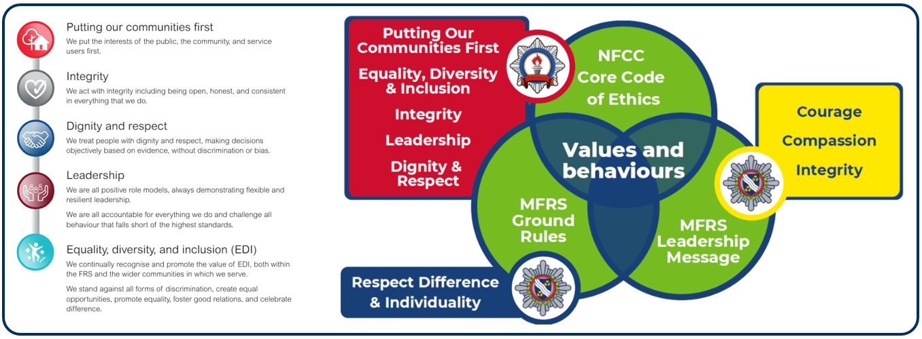

LEADERSHIP BEHAVIOURS
LEADING YOURSELF
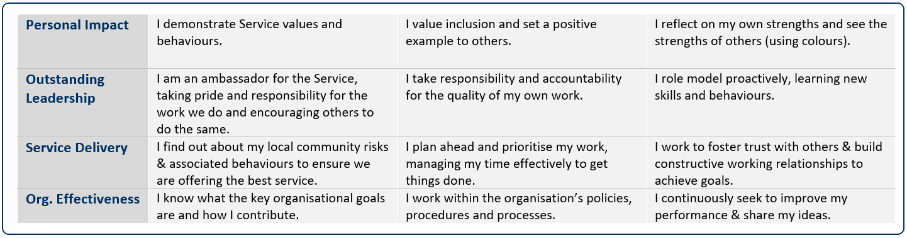

Date job profile prepared / revised:



Role Title: | Volunteer Evaluation Telephone Surveyor | Directorate & Team: | Prevention  Home Safety

 | QUALIFICATIONS & TRAINING | ESSENTIAL/DESIRABLE | ASSESSED BY
 | Good level of education in English & Mathematics | E | A & PD
 | An E.C.D.L Certificate or equivalent | D | A & PD
 | KNOWLEDGE & EXPERIENCE | ESSENTIAL/DESIRABLE | ASSESSED BY
 | An understanding of Data Protection | D | A & I
 | Experience of dealing with/making phone calls | E | A & I
 | Experience of dealing with enquiries from members of the public | D | A& I
 | Experience of data inputting | D | A & I
 | SKILLS & ABILITIES | ESSENTIAL/DESIRABLE | ASSESSED BY
 | Highly Motivated | E | A & I
 | Excellent Listening Skills | E | A & I
 | Good interpersonal skills with the ability to communicate effectively verbally with a wide range of people in a clear and accurate manner | E | A & I
 | Excellent telephone manner | E | A & I
 | Accuracy and attention to detail | E | A & I
 | Ability to use a keyboard with both precision and speed | E | A & I
 | Good literacy skills | E | A & I
 | Good IT skills including the use of Microsoft packages | E | A & I
 | WORK RELATED CIRCUMSTANCES | ESSENTIAL/DESIRABLE | ASSESSED BY
 | A commitment to model our values and behaviours; promoting a culture which embraces collaboration, inclusivity, high performance, and wellbeing, striving to make a real difference to the communities we serve. | E | A & I
 | Meet the medical standard required for the volunteering role | E | MFRS
 | Basic/ Standard / Enhanced Disclosure Barring Service check (verification of unspent criminal records will be undertaken in the in the form of a basic/ standard / enhanced disclosure barring service check) | E | MFRS

A | Application | I | Interview | PD | Produce Documentation | MFRS | If successful & conditionally offered the volunteer role, MFRS will complete the necessary checks

