

JOB TITLE: | Advocate
SALARY GRADE: | 6
JE REFERENCE: | A418
DIRECTORATE: | Community Risk Management
TEAM: | Prevention
LOCATION OF WORK: | Merseyside wide
HOURS OF WORK: | 35
DIRECTLY RESPONSIBLE TO: | Prevention Team Manager

LEADERSHIP BEHAVIOUR LEVEL: | Leading Yourself

MAIN JOB PURPOSE
To generate and deliver Community Risk Management initiatives that are applicable to the communities throughout Merseyside working in partnership with outside agencies and other Home Safety Advocates.

KEY AREAS OF RESPONSIBILITY
1. To deliver Home Safety Advice to vulnerable people within Merseyside.

2. To assist when necessary other Merseyside Fire and Rescue Service personnel in the delivery of Home Safety Services.

3. To deliver the Safety Awareness & Fire Education (SAFE) initiative to adolescent fire setters within Merseyside.

4. To strengthen existing partnerships and support local health needs by delivering Safe & Well initiatives.

5. To provide appropriate feedback to associated partners following interventions and work together to reduce fire related risks.

6. To provide correctly completed and timely reports following interventions.

7. To be responsible for assessment, provision and installation of safety equipment.

8. To deliver Fire Safety Education Sessions to high risk groups within Merseyside.

9. To support other community risk management activities to make communities safer from fire.

10. To undertake any other duties and training deemed suitable by the Authority commensurate with the grade.

The post holder will be committed to, encourage and promote the values of MFRS, the National Core Code of Ethics for Fire & Rescue Services, and act in accordance with our Ground Rules.

VALUES, BEHAVIOURS AND CODE OF ETHICS
As detailed in the Authority’s CRMP, the Leadership Message clearly states our Values.

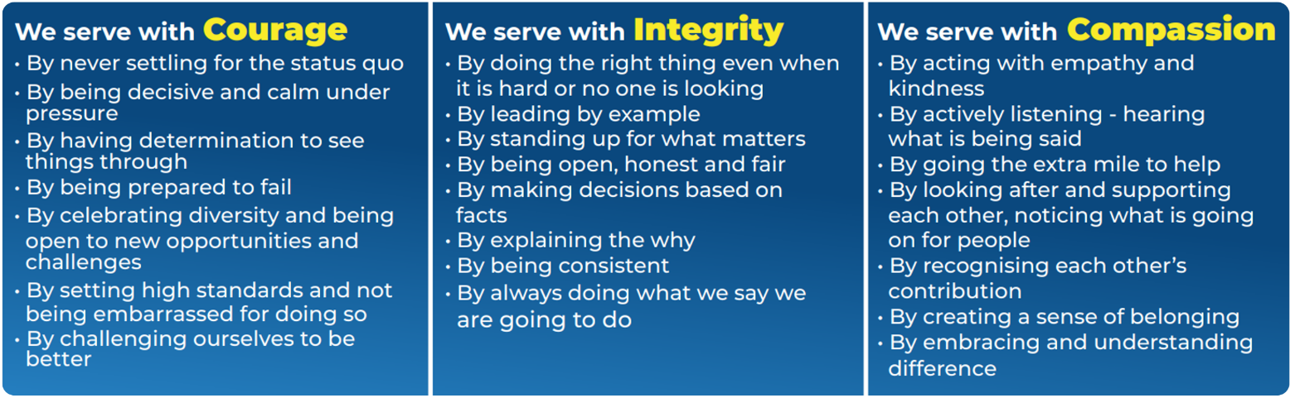

The National Core Code of Ethics for Fire & Rescue Services sets out five Key Principles, which provide a basis for promoting good behaviour and challenging inappropriate behaviour. The code is complemented by MFRA’s Ground Rules, which outlines how we welcome difference and individuality, create a sense of belonging in the most inclusive way and provide some key, simple rules surrounding how we act.

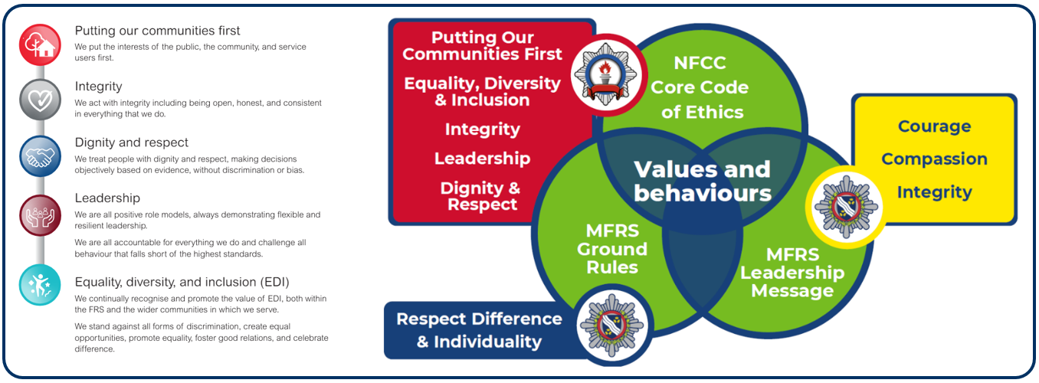

LEADERSHIP BEHAVIOURS
LEADING YOURSELF
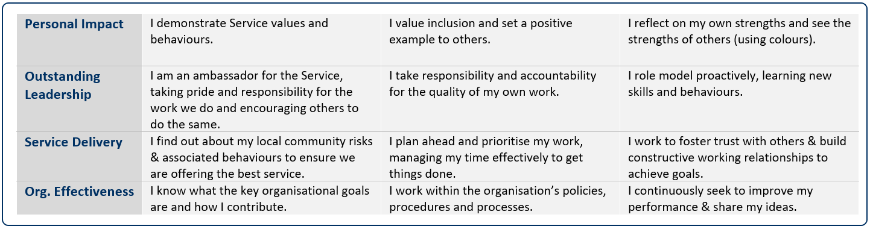

Date job profile prepared / revised: | S Nugent 17.4.25

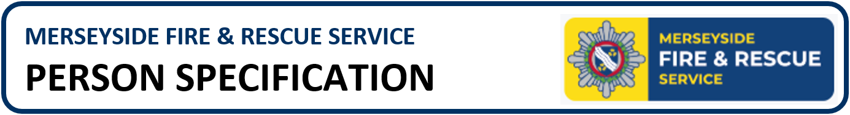

Job Title: | Home Safety Advocate | Team: | Prevention
Salary: | Grade 6 | Directorate: | Community Risk
JE Reference: | A418

 | QUALIFICATIONS & TRAINING | ESSENTIAL/DESIRABLE | ASSESSED BY
 | Health and Safety qualification | D | PD
 | A current certificate in First Aid training | D | PD
 | KNOWLEDGE & EXPERIENCE | ESSENTIAL/DESIRABLE | ASSESSED BY
 | Experience of working with vulnerable people. | E | A&I
 | Previous experience working within Community Risk Management | D | A&I
 | Previous experience in conducting presentations or communicating specific information to groups | E | A&I
 | Previous experience of working/engaging with children | D | A&I
 | Knowledge of relevant legislation, i.e. Data Protection etc | D | A&I
 | Understanding of confidentiality and privacy | E | A&I
 | Knowledge of the communities in Merseyside | D | A&I
 | An understanding of the consequences of fire | E | A&I
 | Good knowledge of Fire /Home Safety | D | A&I
 | Knowledge of Health and Safety and Risk Assessment | D | A&I
 | Knowledge of the Safety Advice & Fire Education (S.A.F.E) initiative | D | A&I
 | Knowledge of the aims and objectives of Merseyside Fire and Rescue Service and Home Safety | D | A&I
 | SKILLS & ABILITIES | ESSENTIAL/DESIRABLE | ASSESSED BY
 | Excellent interpersonal skills with the ability to communicate effectively both verbally and in writing with a wide range of people in a clear and accurate manner | E | A&I
 | The ability to exchange complicated and sensitive information both verbally and in writing in a professional and confidential manner | E | A&I
 | Highly motivated | E | A&I
 | Ability to work to deadlines, which are subject to conflict | E | A&I
 | Excellent organisation and time management skills, with the ability to prioritise | E | A&I
 | Diplomacy skills | E | A&I
 | Ability to use own initiative | E | A&I
 | Strong creative and analytical skills with regards to problem solving | E | A&I
 | Good level of literacy and numeracy skills | E | A&I
 | Good IT skills in the use of Microsoft Outlook, Word and Excel. | E | A&I
 | WORK RELATED CIRCUMSTANCES | ESSENTIAL/DESIRABLE | ASSESSED BY
 | A commitment to model our values and behaviours; promoting a culture which embraces collaboration, inclusivity, high performance and wellbeing, striving to make a real difference to the communities we serve. | E | A&I
 | Meet the medical and fitness standard required for the role | E | MFRS
 | Disclosure Barring Service check, verification of unspent criminal records will be undertaken in the in the form of a standard disclosure barring service check | E | MFRS
 | The post holder will be expected to work flexibly Monday – Sunday (inclusive) from the hours of 7:00am to 11:00pm | E | A&I
 | Full UK manual Driving Licence | E | PD

A | Application | I | Interview | PD | Produce Documentation

