

JOB TITLE: | Volunteer Fire Cadet Instructor
SALARY GRADE: | Volunteer Role
JE REFERENCE:
DIRECTORATE: | Youth Engagement
TEAM: | Fire Cadets
LOCATION OF WORK: | Various Fire Cadet Units across Merseyside
HOURS OF WORK: | 3 hrs per week
DIRECTLY RESPONSIBLE TO: | Fire Cadet Unit Leader
RESPONSIBLE FOR: | Supporting and supervising Fire Cadets aged 13–17 years during Fire Cadet activities and events.

LEADERSHIP BEHAVIOUR LEVEL:

MAIN JOB PURPOSE
To support the planning, delivery and supervision of Fire Cadet activities, providing young people aged 13–17 with safe, enjoyable and educational experiences that promote confidence, teamwork, leadership, community responsibility and personal development.
The post holder will act as a positive role model, supporting young people to develop life skills, improve self-esteem and make positive life choices through participation in the nationally recognised Fire Cadet programme.
The post holder will be committed to, encourage and promote the values of MFRS, the National Core Code of Ethics for Fire & Rescue Services and act in accordance with our Ground Rules.

KEY AREAS OF RESPONSIBILITY
- Support the delivery of the Fire Cadet programme in accordance with national Fire Cadet guidance and MFRS policies.
- Act as a positive role model for young people and promote appropriate standards of behaviour.
- Assist in planning and delivering practical, classroom-based and community activities.
Support activities including:
- Firefighting drills
- Hose and hydrant drills
- Foam and extinguisher exercises
- Search and rescue activities
- First aid awareness
- Fire safety education
- Water safety awareness
- Road safety awareness
- Team-building exercises
- Community engagement projects
- Fundraising events
- Support the delivery of nationally recognised Fire Cadet qualifications and awards where applicable.
- Ensure the safety and wellbeing of all young people participating in activities.
- Maintain awareness of safeguarding responsibilities and follow relevant policies and procedures.
- Promote equality, diversity, inclusion and respect amongst cadets and volunteers.
- Encourage self-discipline, teamwork, leadership and social responsibility.
- Support young people to develop communication, problem-solving and interpersonal skills.
- Assist with attendance records, activity reports and other administrative tasks as required.
- Participate in public engagement activities, fundraising events and community projects.
- Represent Merseyside Fire & Rescue Service professionally at local, regional and national events.
- Maintain confidentiality and comply with data protection requirements.
- Attend induction, mandatory training and continuing development opportunities.
- Promote safe working practices and comply with all health and safety requirements.

VALUES, BEHAVIOURS AND CODE OF ETHICS
As detailed in the Authority’s CRMP, the Leadership Message clearly states our Values.

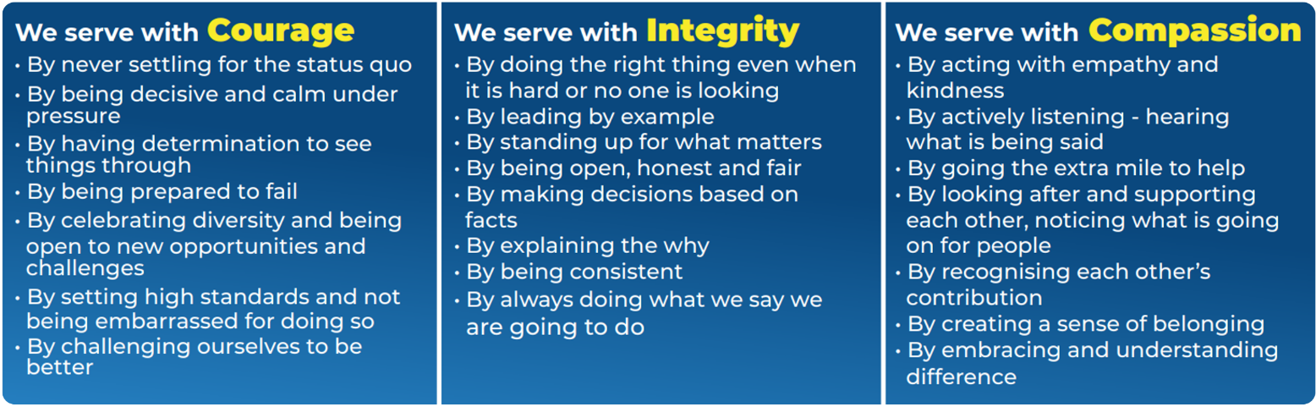

The National Core Code of Ethics for Fire & Rescue Services sets out five Key Principles, which provide a basis for promoting good behaviour and challenging inappropriate behaviour. The code is complemented by MFRA’s Ground Rules, which outlines how we welcome difference and individuality, create a sense of belonging in the most inclusive way and provide some key, simple rules surrounding how we act.

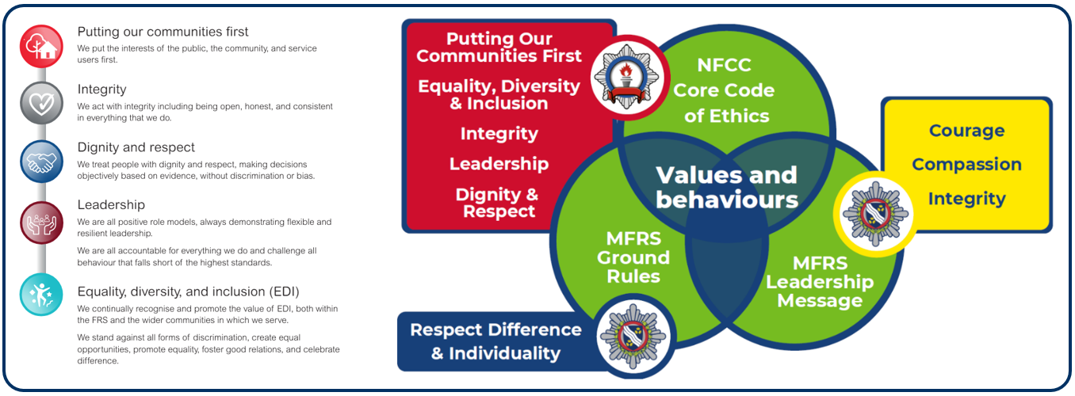

LEADERSHIP BEHAVIOURS
LEADING YOURSELF
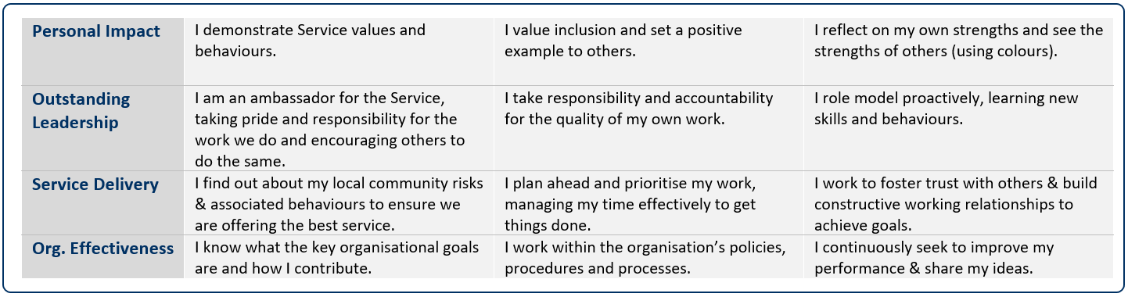



Job Title: | Volunteer Cadet Instructor | Team: | Youth – Fire Cadets
Salary: | Voluntary | Directorate:
JE Reference:

 | QUALIFICATIONS & TRAINING | ESSENTIAL/DESIRABLE | ASSESSED BY
 | Willingness to undertake induction and mandatory training | E | A & I
 | Willingness to complete MFRS e-learning modules and development activities | E | A & I
 | First Aid qualification or willingness to obtain | E | A & I
 | KNOWLEDGE & EXPERIENCE | ESSENTIAL/DESIRABLE | ASSESSED BY
 | Experience of supporting, motivating or encouraging young people | D | A & I
 | Experience of working effectively as part of a team | E | A & I
 | Experience working with children or young people | D | A & I
 | Experience of planning and delivering activities | D | A & I
 | SKILLS & ABILITIES | ESSENTIAL/DESIRABLE | ASSESSED BY
 | Good communication and interpersonal skills | E | A & I
 | Ability to build positive relationships with young people | E | A & I
 | Ability to motivate, encourage and support others | E | A & I
 | Ability to complete basic administrative tasks | E | A & I
 | Basic IT skills and ability to use electronic systems | E | A & I
 | Commitment to participate in cadet activities and events | E | A & I
 | WORK RELATED CIRCUMSTANCES | ESSENTIAL/DESIRABLE | ASSESSED BY
 | A commitment to model our values and behaviours; promoting a culture which embraces collaboration, inclusivity, high performance and wellbeing, striving to make a real difference to the communities we serve. | E | A & I
 | Meet the medical and fitness standard required for the role | E | MFRS
 | Basic/ Standard / Enhanced Disclosure Barring Service check (verification of unspent criminal records will be undertaken in the in the form of a basic/ standard / enhanced disclosure barring service check) | E | MFRS
 | Ability to travel to allocated Fire Cadet locations where required | E | A & I

A | Application | I | Interview | PD | Produce Documentation | MFRS | If successful & conditionally offered the role, MFRS will complete

Date job profile prepared / revised:

