

JOB TITLE: | Workshop HGV Coachbuilder
SALARY GRADE: | Craft 2
JE REFERENCE:
DIRECTORATE: | Operational Preparedness
TEAM: | Transport: Workshops
LOCATION OF WORK: | Workshops, Vesty Road
HOURS OF WORK: | 35 hours per week.
DIRECTLY RESPONSIBLE TO: | Workshop Coordinator

LEADERSHIP BEHAVIOUR LEVEL:

MAIN JOB PURPOSE
The body repair, inspection, servicing and modification of Fire Service and partners vehicles and equipment. Repair and servicing of Operational ladders

The post holder will be committed to, encourage and promote the values of MFRS, the National Core Code of Ethics for Fire & Rescue Services, and act in accordance with our Ground Rules.

KEY AREAS OF RESPONSIBILITY
1. To carry out vehicle body repair, inspection, servicing, Welding and modification tasks as detailed by the Chargehand, Co-Ordinator, Workshop Manager or Transport manager.

2. Commissioning and de-commissioning of vehicles

3 Carry out vehicle installs.

4 The Manufacture of bespoke projects for MFRS departments.

5. The service and Maintenance of operational ladders.

6. The collection and delivery of fire vehicles or ancillary equipment, including the collection and
delivery of spare parts.

7. To be responsible for all documentation connected with the post (job card completion etc.).

8. To bring to the attention of management any defects that would or could cause damage to the
equipment or that may result in or have the potential to cause accidents.

9. To maintain a clean and tidy work area and ensure that general workshop housekeeping is adhered
to.

10. To assist management, as required, by moving over to other sections, to assist in minor repairs,
servicing, inspection or modification of other Fire Service and partner’s equipment.

11. To undertake any other duties deemed suitable by the Authority commensurate with the grade.

The working arrangements are; Monday – Thursday, 8.00am – 4.15pm/Friday – 8.00am – 1.00pm

VALUES, BEHAVIOURS AND CODE OF ETHICS
As detailed in the Authority’s CRMP, the Leadership Message clearly states our Values.

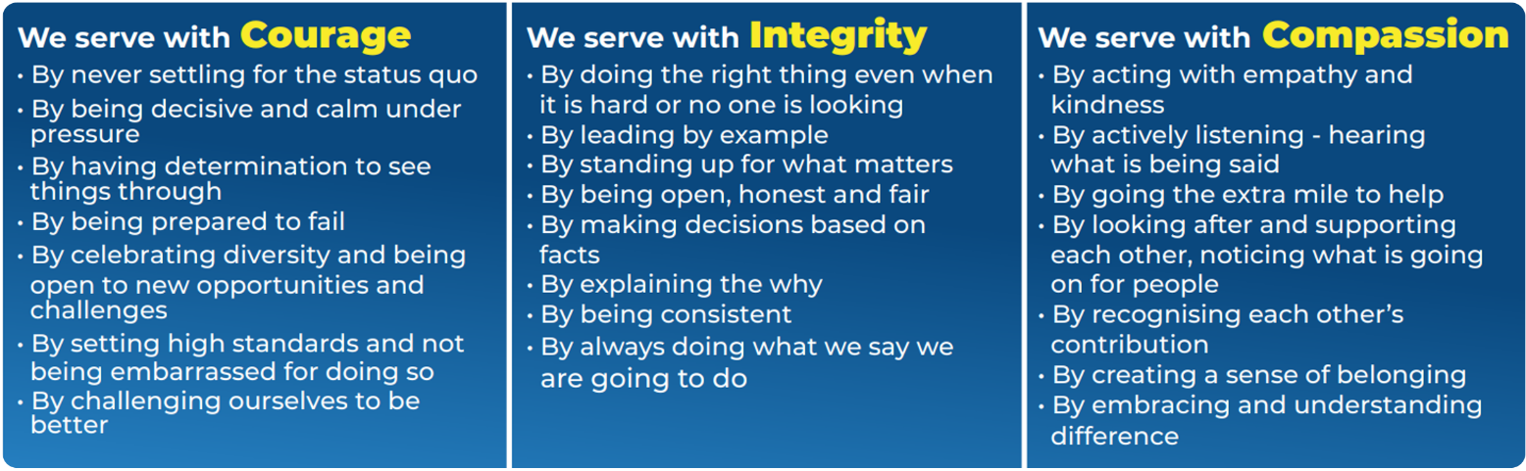

The National Core Code of Ethics for Fire & Rescue Services sets out five Key Principles, which provide a basis for promoting good behaviour and challenging inappropriate behaviour. The code is complemented by MFRA’s Ground Rules, which outlines how we welcome difference and individuality, create a sense of belonging in the most inclusive way and provide some key, simple rules surrounding how we act.

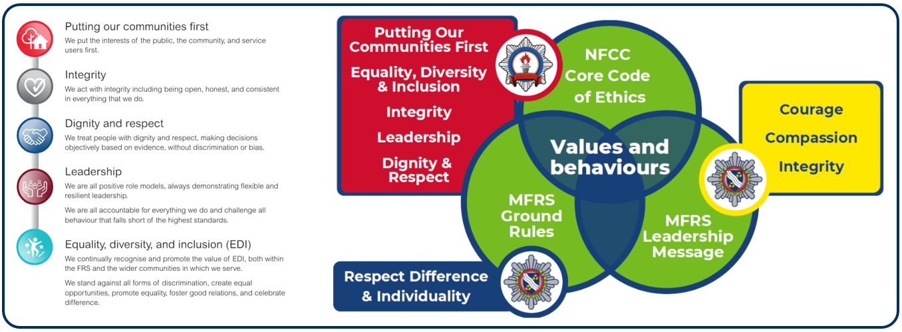

DELETE AS APPROPRIATE

LEADERSHIP BEHAVIOURS
LEADING YOURSELF
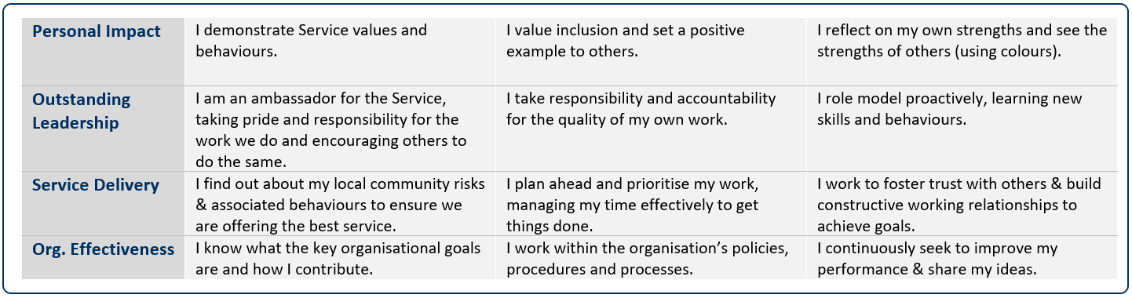

LEADERSHIP BEHAVIOURS
LEADING OTHERS
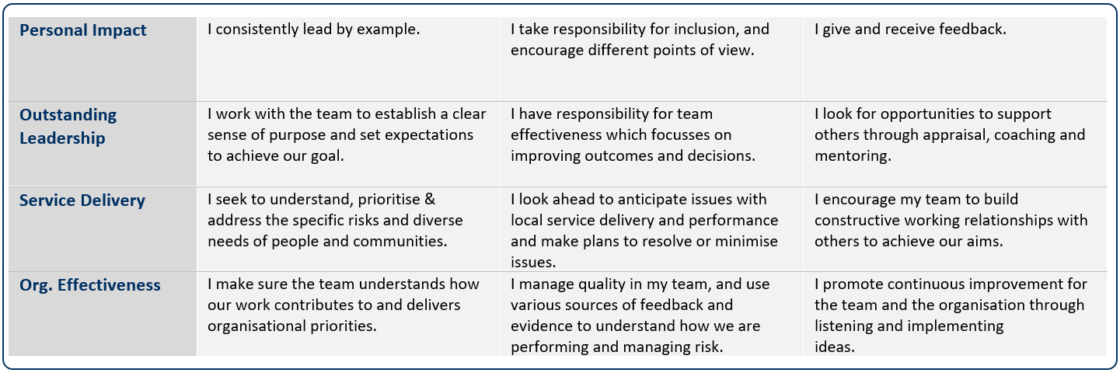

LEADERSHIP BEHAVIOURS
LEADING THE FUNCTION
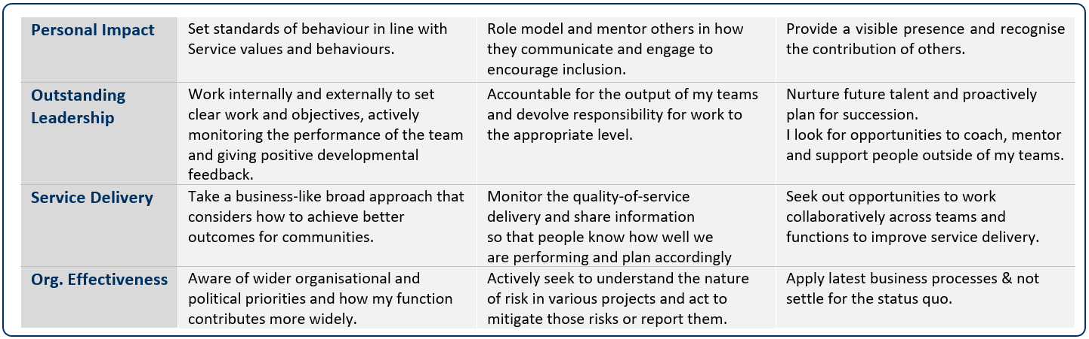

LEADERSHIP BEHAVIOURS
LEADING THE SERVICE
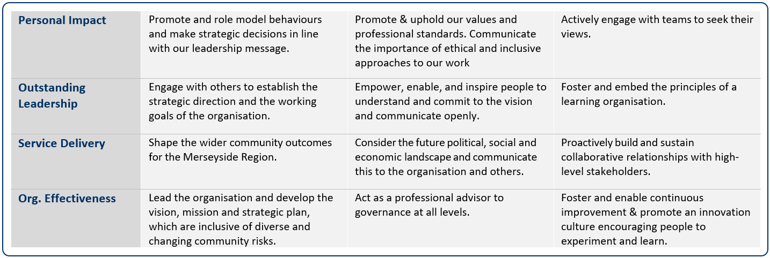

Date job profile prepared / revised: | May 2024 D. Seasman

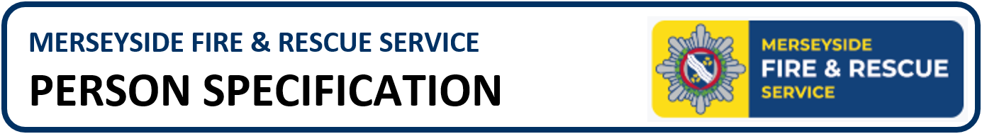

Job Title: | HGV Coachbuilder | Team: | Transport
Salary: | Red Book | Directorate: | Preparedness
JE Reference:

 | QUALIFICATIONS & TRAINING | ESSENTIAL/DESIRABLE | ASSESSED BY
 | Good Standard of Basic Education | E | A&I
 | Fully Qualified Coachbuilder/bodybuilder, City and Guilds or NVQ level 3 | E | PD
 | Minimum apprentice training | E | A&I PD
 | Welding, Gas, Electric, MIG | E | PD
 | KNOWLEDGE & EXPERIENCE | ESSENTIAL/DESIRABLE | ASSESSED BY
 | Knowledge of basic Health and Safety in the workshop | E | A & I
 | Knowledge of woodworking and sheet metal machinery | E | A & I
 | Knowledge of vehicle construction | E | A & I
 | Relevant experience of working in a HGV vehicle transport workshop- Minimum 3 years | E | A & I
 | Experience of vehicle body accident repair and modifications. Minimum3 Years | E | A & I
 | Sheet metalwork manufacture and repair | E | A & I
 | Plastic/composite body repair | D | A & I
 | SKILLS & ABILITIES | ESSENTIAL/DESIRABLE | ASSESSED BY
 | Proficient in the use of various hand tools. | E | A & I
 | Ability to work with engineering drawings. | E | A & I
 | Ability to manufacture bespoke assemblies | D | A & I
 | WORK RELATED CIRCUMSTANCES | ESSENTIAL/DESIRABLE | ASSESSED BY
 | A commitment to model our values and behaviours; promoting a culture which embraces collaboration, inclusivity, high performance and wellbeing, striving to make a real difference to the communities we serve. | E | A & I
 | Meet the medical and fitness standard required for the role | E | MFRS
 | Basic/ Standard / Enhanced Disclosure Barring Service check (verification of unspent criminal records will be undertaken in the in the form of a basic/ standard / enhanced disclosure barring service check) | E | MFRS
 | LGV License | D | P D
 | Current UK manual Driving License | E | P D
 | Own Comprehensive tool kit | E | A & I

A | Application | I | Interview | PD | Produce Documentation | MFRS | If successful & conditionally offered the role, MFRS will complete

